Professor First AUTHOR, PhD
E-mail: first.author@ase.ro
Department of Economic Informatics and Cybernetics
The Bucharest University of Economic Studies

Associate Professor Second AUTHOR, PhD
E-mail: second.author@ase.ro
Department of Economic Informatics and Cybernetics
The Bucharest University of Economic Studies

PAPER TITLE – TIMES NEW ROMAN 12 BOLD

Abstract. The journal of Economic Computation and Economic Cybernetics Studies and Research was established in 1966 to publish original high-quality papers in the field of mathematical modelling of economic phenomena and processes, operations research, mathematical programming, games theory, marketing, methods and techniques of statistical analysis, artificial intelligence, expert systems, neuronal networks, software instruments for modelling and analyzing the economic phenomena etc.
Keywords: Economic, Computation, Cybernetics, Studies, Research.

JEL Classification: C02, C11, C45, C46, C63.

1. Introduction

Manuscripts must be written in good English. Contributions are accepted for review with the understanding that the same paper has not been published elsewhere.
The formatted paper must have maximum 16 pages(even number of pages), including References that must have maximum 25 citations. You have to submit your paper according to our formatting conditions: font 11, Times New Roman, page set up: top - bottom: 5 cm- left-right: 4 cm, line spacing: single, orientation: portrait.
You have to write the didactic degrees (Professor, PhD, PhD Candidate) and the affiliation of the authors to be added to the respective names, I also need the name and surname of all the authors, not the initials, the tables and figures must enter the set-up of the page and not outside it and, of course, the JEL classification of the paper.

2. Manuscript formatting requirements

Manuscripts should be submitted by email as a single attachment to the Editor-in-chief of the journal, to the following email: ececsr@ase.ro.
All manuscripts must be prepared according to the following guidelines. All submissions must be in Microsoft word format, A4 paper format, single column documents, with page set up: top 5 cm, bottom 5 cm, left 4 cm, right 4 cm, single interline spacing, using 11 point type in Times New Roman.
The paper should include author(s) name and affiliation, address, email of the corresponding author. Also, an abstract of about 150 words, clearly stating the significance of the paper and about 5-8 key words should be provided below the abstract. Keywords should express the precise content of the manuscript as they are used for indexing purposes. The abstract must not include mathematical expressions or bibliographic references.
References should be listed in a separate bibliography, at the end of the paper, referred to by numbers in square brackets and listed in alphabetical order.
In the text, where the author’s name appears, the data should follow in parentheses, e. g., Donaldson (1977), or (Chang and Chang, 2012), or (Li et al, 2015).
Authors must provide high quality artwork for all illustrations. Poor definition reproductions are not suitable. Tables and figures should be numbered separately. Each table and figure should be given a title.

Table 1.Coding modes for non-numerical
Characteristic | Coding mode
DM
TSM
TCM

The Figure 1 below shows the Euclidean distances between the user U and the user profiles from the database.

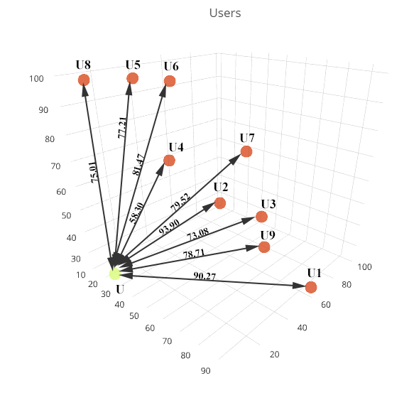
Figure 1. Euclidean distances between the user U and user profiles from database

Papers should not be longer than 16 pages, including all references, tables, figures etc.

3. Editorial Review Process

Each submission is peer-reviewed by at least two referees; usually a review process takes about 6 months to be completed. As a result of the technical review process, a manuscript may be accepted without change, recommended for modification and further review, or rejected.
To complete the double-blind review process it takes approximately six months. Once that process is complete, the contact author will receive an email indicating whether the paper has been:
- accepted for publication without change;
- provisionally accepted for publication pending certain changes;
- rejected for publication.
Editorial Review Process: our reviewers will evaluate the submitted articles according to the following criteria:
- originality;
- presentation;
- linguistic quality;
- scientific significance;
- relevance to our journal.

4. Conclusions

ECECSR is a refereed journal dedicated to publication of original articles in the fields of economic mathematical modeling, operations research, microeconomics, macroeconomics, mathematical programming, statistical analysis, game theory, artificial intelligence, and other topics from theoretical development to research on applied economic problems.
Published by the Academy of Economic Studies in Bucharest, it is the leading journal in the field of economic modeling from Romania.

REFERENCES

[1] Bernardo, M. J. (2005), Reference Analysis. Handbook of statistics, 25:17–90;
[2] Chang, C.K., Chang, T. (2012), The Impact of Structural Change on the Calibration of Interest Rates Models in Taiwan. Economic Computation and Economic Cybernetics Studies and Research, 46(4): 121-142;
[3] Donaldson, W.A. (1977), Inventory Replenishment Policy for a Linear Trend in Demand.Operations Research, 28, 663-670;
[4] Li, K., Lin, Z., Wang, X. (2015), An Empirical Analysis of Users' Privacy Disclosure Behaviors on Social Network Sites; Information & Management, 52: 882-891.

